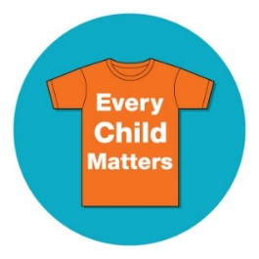

Dear Colleagues,

Orange shirt day has been declared on September 30th annually and is designed to commemorate the residential school experience, to witness and honour the healing journey of the survivors and their families, and to commit to the ongoing process of reconciliation. Chief Justice Murray Sinclair challenged all of the participants to keep the reconciliation process alive, and as a result of the realization that every former student had similar stories.

This date is held in recognition of the harm the residential school system did to children's sense of self-esteem and wellbeing, and as an affirmation of our commitment to ensure that everyone around us matters. We have compiled some useful links and resources that you may wish to explore, as Orange Shirt Day presents a great opportunity to ground the start of your year in our shared history and the development of common understanding on how we can move forward together. If you have questions or would like further resource ideas, please contact a member of the Indigenous Education Team.

In spirit of reconciliation,

Indigenous Success Team

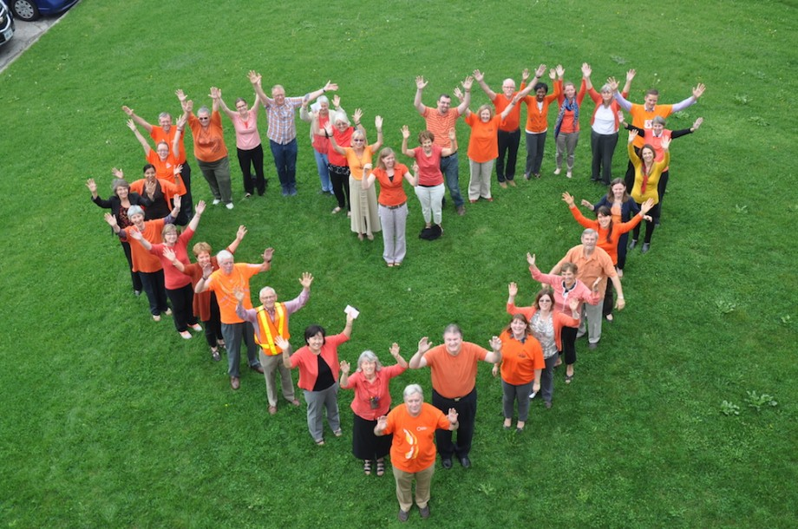

General Information and Resources
Official Web site: http://www.orangeshirtday.org/
Video about Phyllis’s Experience:
https://www.youtube.com/watch?v=ll1pUrK29MM&feature=youtu.be
Great Resources and lessons from Manitoba Teachers:
http://www.mbteach.org/mtscms/2016/09/10/lesson-plans-and-resources-for-orange-shirt-day/
Where are the Children - http://wherearethechildren.ca/en/
Shi shi etko with live actors - https://www.youtube.com/watch?v=tKErhCGjSDE&feature=youtu.be
Hidden History/Project of Heart – BCTF https://bctf.ca/HiddenHistory/
Gladys We Never Knew – BCTF https://bctf.ca/GladysWeNeverKnew/
Elementary Resources
Things you can do in your class:
- Wear and orange shirt or an orange ribbon
- Make orange streamers
- Students can do an orange hand print and write about how every child matters because… or I matter because…
- Watch the video about Phyllis’s experience with the orange shirt.
Books to Read
Shi shi etko - good introduction students can relate to being excited going to school for the first time. They can make a memory bag or draw what they would put in their memory bags. There is also a short 6 min film on NFB in the coast salish language.
Shin chi’s canoe – here they meet Shin chi who is Shi shi etko’s brother he is going away to school too. This story focuses on life in a residential school from a child’s perspective.
Picture books: When I was eight, Not my girl
Short Chapter books: Fatty Legs, Stranger at Home, My Name is Sepeetza.
Other recommended book titles: http://www.cbc.ca/news/indigenous/10-books-about-residential-schools-to-read-with-your-kids-1.3208021
FNESC Grade 5 Residential Schools Teachers Resource http://www.fnesc.ca/grade5irsr/

Secondary Ideas/Resources:
Activities for your school, homeroom or socials class:
- Share a fact a day on the announcements
How many IRS were there in Canada?
When did the last one close?
How many FNMI children went to IRS?
Who was sent to IRS?
Why were they sent to IRS?
How many children died at IRS?
What is reconciliation?
- Decorate “orange” hands with messages from the kids – create a mural (ie. tree)
- Wear orange – (consider ordering a t-shirt) – wear an orange ribbon or button

FNESC Residential Schools Resource Package (Includes short videos and links to curriculum and lessons) http://www.fnesc.ca/grade-10irsr/
FNESC Grade 11/12 Resources http://www.fnesc.ca/grade-11-12-indian-residential-schools-and-reconciliation/

